Regulations:
A14

H.T No

Sreenidhi Institute of Science and Technology
(An Autonomous Institution)
Code No: 4A714 Date: 21-Dec-2018 (FN)

B.Tech IV-Year I-Semester External Examination, Nov/Dec - 2018 (Supplementary)
Power Systems – IV (EEE)

Time: 3 Hours Max.Marks:70

Note: a) No additional answer sheets will be provided.
b) All sub-parts of a question must be answered at one place only, otherwise it will not be valued.
c) Missing data can be assumed suitably.

Part - A Max.Marks:20

Answer all QUESTIONS.

1. | Define a tree and cut-set with suitable example. | [2M]
2. | Why symmetrical components are necessary? | [2M]
3. | Give the expression for fault current for the double line to ground fault. | [2M]
4. | What is the necessity of keeping frequency constant? | [2M]
5. | What are advantages of two area system? | [2M]
6. | Define hydrothermal scheduling. | [2M]
7. | List the advantages of per unit system. | [2M]
8. | Explain the necessity of load flow. | [2M]
9. | Define load frequency control. | [2M]
10. | List the advantages of fast Decoupled load flow. | [2M]
Part – B Max.Marks:50
ANSWER ANY FIVE QUESTIONS. EACH QUESTION CARRIES 10 MARKS.

11. | a) | Derive the Expression for bus admittance matrix by singular transformation method. | [5M]
 | b) | Explain the merits and demerits of building of Z_{bus} algorithm. | [5M]
12. | a) | A 4-pole , 50Hz , 60MVA turbo generator has moment of inertia of 9x10³ kg-m², Determine,  i) The Kinetic Energy in MJ at rated speed.The inertia Constant M and H.  ii) The acceleration in degree per sec² and in rpm/sec, if the input power is 20MW and the output power is 15MW. | [5M]
 | b) | Derive an expression for the fault current for a double –line fault as an unloaded generator? | [5M]
13. | a) | Derive static load flow equations from the fundamentals. | [5M]
 | b) | Determine the voltages at the end of the first iteration by G-S method. Take acceleration factor as 1.6.The system data for load flow solution are given in the following table.  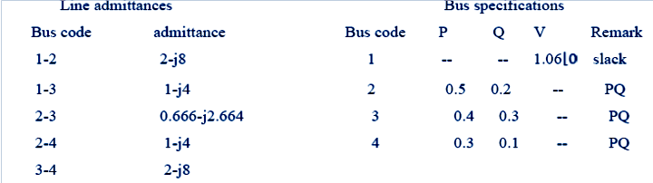 | [5M]
14. |  | A 100 MVA 50Hz turbo alternator operates at no load at 3000 r.p.m. A  load of 25MW is suddenly applied to the machine and the steam valves to the turbine commence to open after 0.6 secs due to the time-lag in the governor system. Assuming inertia constant H of 4.5kW-secs per kVA of generator capacity, calculate the frequency to which the generated voltage drops before the steam flow commences to increase to meet the new load. | [10M]
15. | a) | Explain about load frequency control of 2-area system. | [5M]
 | b) | Explain proportional plus integral control of single area and its block diagram representation. | [5M]
16. |  | The fuel inputs to two plants are given by  F₁ = 0.015 P₁ ² + 16 P₁ + 50  F₂ = 0.025 P₂² + 12 P₂ + 30  The loss coefficients of the system are given by B 11 = 0.005, B 12 = – 0.0012 and B22 = 0.002. The load to be met is 200 MW, determine the economic operating schedule and the corresponding cost of generation if  (i) the transmission line losses are coordinated,  (ii) the losses are included but not coordinated. | [10M]
17. | a) | Describe the procedure of modification of existing Z_{bus} by adding branch from new bus (P) to reference node ,from new bus to existing bus. | [3M]
 | b) | Derive the algorithm to build in Newton-Raphson Iterative method of load flow solution technique. | [3M]
 | c) | Two generating stations having short-circuit capacities of 1200 MVA  and 800 MVA respectively and operating at 11 kV are linked by an interconnected cable having a reactance of 0.5 ohm per phase. Determine the short-circuit capacity of each station. | [4M]
18. | a) | Explain the speed governing system for load frequency control of single area system. | [3M]
 | b) | What is economic dispatch control? | [3M]
 | c) | Explain the reasons for limits on frequency. | [4M]
-- 00 -- 00 –

